# ERD

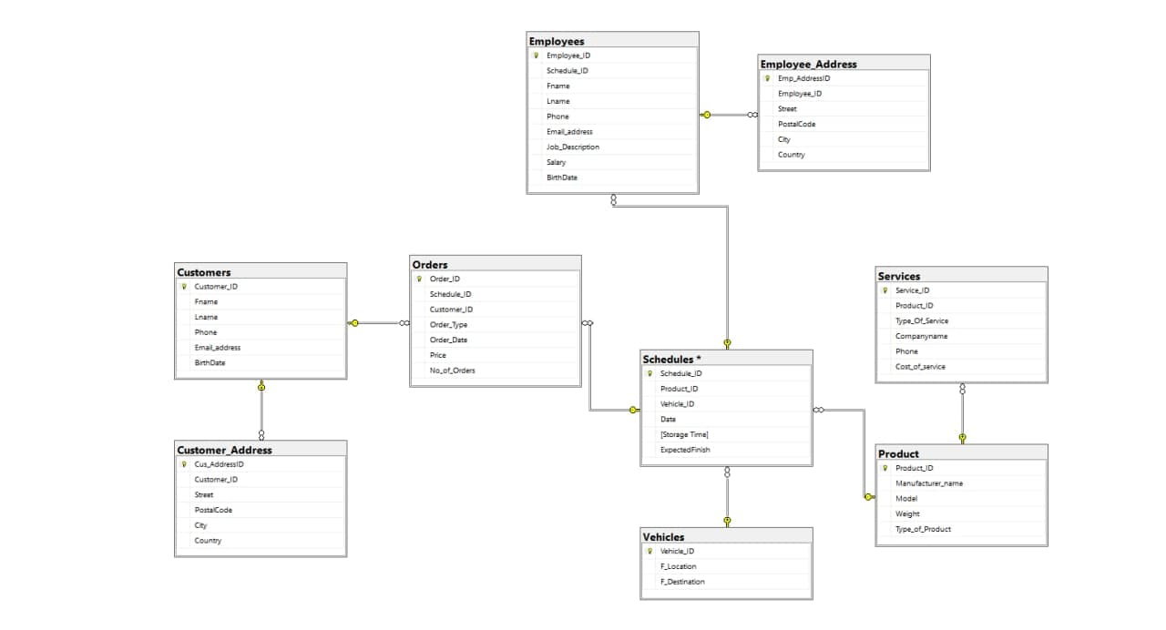

* Randfontien Wheels needs to keep track of stock, Wheels, oils and Rims.
* Randfontien Wheels is divided into different sections of which model of a car and the parts of a car.
* The Randfontien Wheels arranges activities such as workshops during the holidays and need to keep track of the events they have planned and what they will need to show case the new models of car parts.
* Currently, there are 5 Randfontien Wheels that work in two shifts, Morning 8:00 – 13:00 and Afternoon 13:00 – 18:00. They take turns working the weekend shift.

During your meeting with senior management, you have been able to confirm the following requirements.

* The database should have complete record of patrons, media, and events.
* They must be able to issue the patron with a report that shows the patrons history at the library and any fines incurred.
* They must be able to print a complete list of outstanding media and the fines attached to these media if available. The patron contact details must also be shown.
* They should be able to add a new employee to the database.
* They must be capable to change details of current employees.
* They must be able to add new patrons and change details of current patrons.
* The employees must be able to create a record for lending out media to a patron.
* They want to be able to create new events.
* They want to have a report of their complete list of expenses (salaries) and income (fines and events) for a specified date period.
* When a book is already loaned out, you must be able to reserve it for a patron.
* When a new patron is added, you need to first ensure that you do not already have a record for the patron.
* You need to be able to search all the media for a specific book title or author.